v

A Final Revision for grade 8The first semester

Final Revision for grade 8
The first semester
Students Name : ……………….



Part 1: Reading
Text 2 Read the comprehension and choose the correct answer.
- I am Anna. Growing in USA, I always wanted to experience another culture. The opportunity came when I was 15 years old. After a few months of planning and preparing, I was ready to spend the second semester of my first year of high school as an exchange student in Australia. To tell her parents that she wanted to go on an exchange program was challenging.
I seek for help on which organization might suit best for me. We found ‘Youth for Understanding’ which offered a wonderful scholarship that paid half of my program.
Landing in Perth was one of the most exciting moments of my life. The family I would live with was waiting for me, and the new school would start in five days.
1-Anna was in the semester of her first year of high school.

  - first b. second c. third

- To tell her parents that she wanted to go on an exchange program was .

  - tiring b. impossible c. challenging
- Youth for Understanding was going to give Anna that would half of the money
a. scholarship b. program c. organization
- She reached Perth days before her school was going to start.
- a. 2 b. 4 c. 5

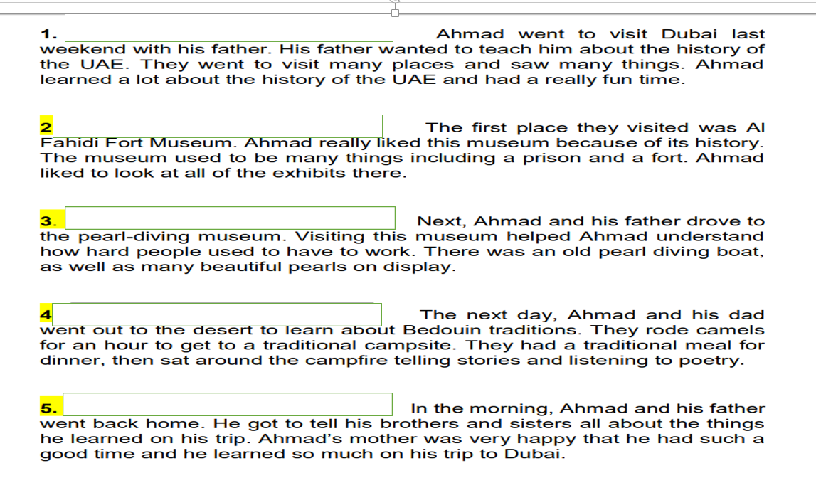
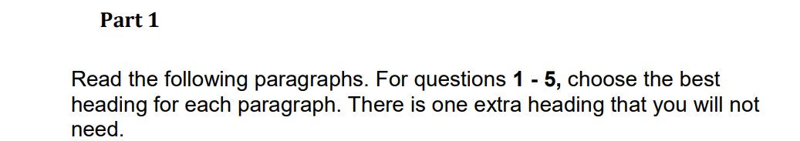

A- lesson on hard work at sea
B-Sharing his experience
C-His father’s plan
D-Nomadic life and traditions
E- A museum that not always am museum
E- living in an Oasis

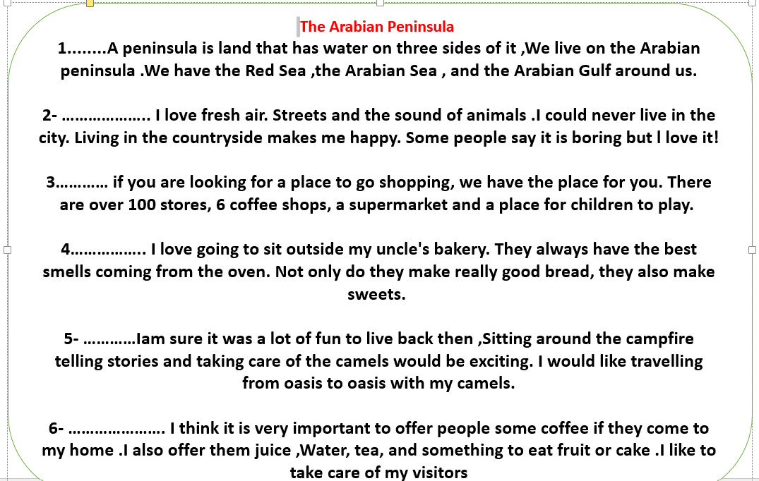
Match the best heading to each paragraph:

A- the Best Mall in the world
B Country living is the Best
C- Hospitality at Home
D More Than Bread
E Hot Coffee For everyone
F Bedouin Life
G The Arabian Peninsula
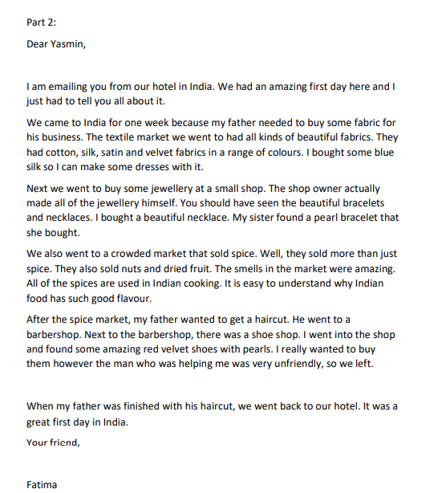

6- How long has Fatima in India?
A-one month B- one week c- one day
7- Why did Fatima and her family travel to India?
A to buy jewellery B- for a family holiday C- for her father’s business
8- Why did Fatima buy some Fabric?
A- to make clothes B- because it was beautiful C- her father needed it for his business
9-What did Fatima ;s sister buy at the jewellery shop?
A- blue silk Fabric B- a pearl braclete c- a beautiful necklace
10-What is a good title for this email?
A- No Shoes for Fatima b- Busy first Day c- The flavour of Indian Food

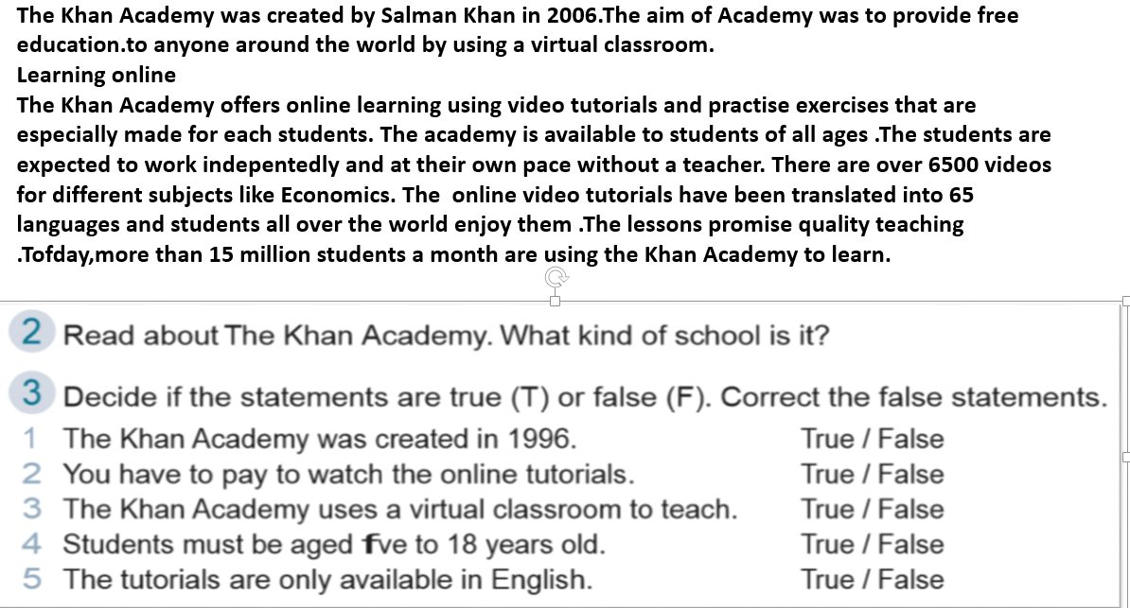
Online Education

- When was the Khan Academy started?
  - 2005 B- 2006 c- 2007
- Khan Academy wanted to provide ________ .
  - Cheap education b- Expensive education C- free education
- Khan Academy offers ________ .
  - Online tutorials B- real life classes C- Free books
- Who is Khan Academy for?
  - Teachers who need help b- Students of all ages c- People with learning difficulties
- What subjects did the text say are available?
  - English and Arabic C- Biology and Chemistry c- Physics and Psychology
- The lessons promise _________ .
  - 65 languages B- 15 millions students C-quality teaching

Studying in Wales...
Many students study in a different country for a year to learn about a new place. We talked to Ali from Dubai. He is studying in Cardiff, Wales. Ali said that
he uses a lot of English. “I speak and write very well now. I feel confident with my English skills!” He likes visiting all the different places in Wales. “Wales has 600 castles. We go to a new one every weekend!” Ali goes to class from Monday to Friday. He likes computer class .,He said” Studying in another country gives young people the chance to learn a new language, experience a new culture and make new friends. They also encourage students to be more independent and confident”, However The most challenging thing for me was not missing my family and friends at home –Another thing is that Ali doesn’t like is the weather. “It’s very cold and it rains a lot.” Ali’s parents are very happy that Ali is studying in Wales. “He tells us all the interesting things he does. We can’t wait to visit him.”
- Why do students study in different countries?
  - To meet friends b- To learn about new places c- To buy a new house
- Where is Ali from?
  - Dublin B-Doha C-Dubai
- What language does he use most?
  - English B- Welsh C- Arabic
- How many castles in Whales?
  - 60 Castles b- 600 Castles c- 6000 Castles
- What does Ali dislike about Whales?
  - The people b- The weather c- The castles
5 When does Ali go to classes?
- Sunday to Thursday B-Saturday to Wednesday c- Monday to Friday

Marrakech
Tip #1: There is so much to see and buy in the markets in Marrakech, but they can be very crowded and the shop keepers will try to stop you as you walk. Avoid eye contact and keep walking if you don’t want to stop. If you want to buy something from a particular shop, you should haggle (argue politely for a better price) with the shop owner for the best price. Don’t worry – this is not rude and can actually be quite fun!
Tip #2: Most tourists travel around the city by taxi. It is best to agree the price with the driver BEFORE you get in to the car. Taxis that wait outside hotels will be more expensive than those you find in the streets. Walking around the old city is safe, but remember to keep your bags and camera out of sight and be careful of the traffic.
Tip #3: Marrakech is famous for its Riads. These are traditional Moroccan houses with an inside garden or courtyard. They range from basic and cheap, to luxury and expensive. There are many modern hotels in the new city, but for a true Marrakech experience, you will find a Riad to suit your budget in the old medina.
What is the purpose of the text?
to give advice on visiting Marrakech
to describe the history of Marrakech
to talk about city tourism in the future
The first paragraph focuses on
avoiding arguments
transport in the city
a shopping experience
(this is too difficult)
How can you save money on a taxi?
get taxis away from hotels
ask the hotel staff to call you one
agree on the price when you arrive at your stop
Where can you stay in a traditional house?
in the new city
in the old medina
in the markets
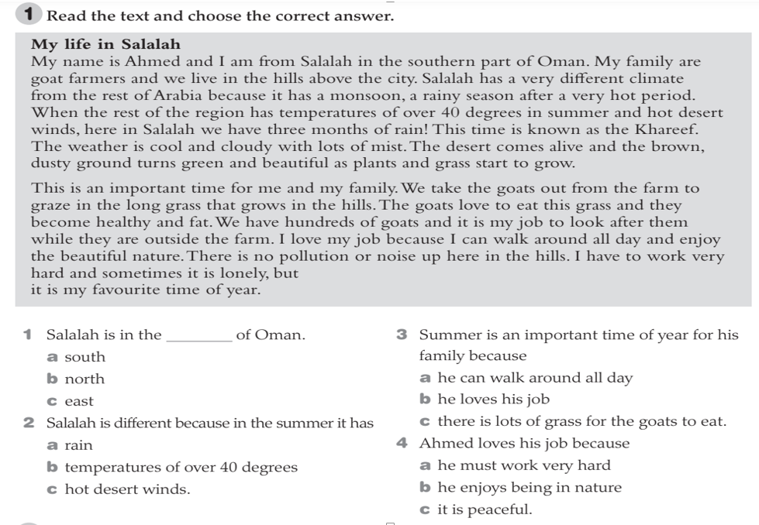
Read the letter then answer the quetions
Dear Grandmother
I Hope you are doing well. I am emailing you to tell you about my new school in Fujairah. It is really nice. We have a lot of really good teachers and all of the students are very nice .I really and I want to tell you all about it .I have a lot of great classes. My Science teacher is Mr Ahmed.He is very funny. He likes to make us laugh while he is teaching. We are learning a lot of really great things in Science class.
My English teacher is Mr Vince .He is such a good teacher. Sometimes his class is boring .He tries to make it fun by playing game My English is getting better.
We also have a painting class. This is my favourite class. I am not great at painting, but it helps me to be calm. My painting teacher is
Mr .Farouq.He is a really good painter. My Arabic teacher is named Mr Abdullah .He is really nice teacher. Sometimes the students are bad in his class and don’t listen to him Not me though I am always good. Well ,I have to go to chess club now. See you soon grandpa.
Love,
Saif
1-Saif ‘s new school is in ………………….
A- Fujairah B –Dibba c- Dubai
2-The …………………..teacher is very funny.
A- math B- Science - C- painting
3-Mr.Vince uses ……….to make his class more fun
A- games B- English c- Science
4- ………………..is good at painting pictures,
A-Mr Vince B- Saif C-Mr. Farouq
5- Students are sometimes bad in …………..
A science class B- Mr Abdullah’s class C-Mr Vince’s class
6- Saif is going to ……………… now.
A- a big school B- Maths class C-Chess Club

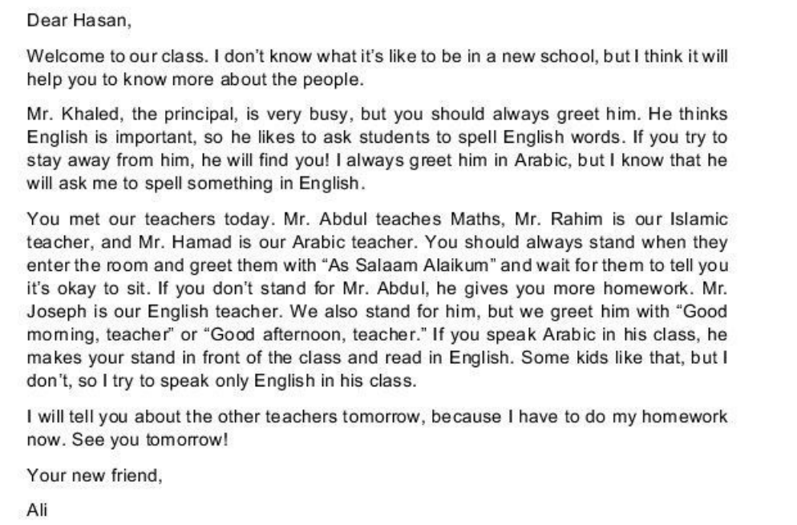
Read the letter then choose the correct answer: ( 6 marks)
1 - Why did Ali write this email? 2 -Who is the principal?
a)because he is a new student A Mr. Hamad
b) because he wants to help a new student B: Mr. Rahim
c) because he wants to practice writing in English c) Mr. Khalid
3-What does Ali think will help Hassan? 4-. Who likes students speak English?
A- To know how to speak English. A -Mr. Hamad and Mr. Joseph
b-To know where the classroom are. B Mr. Rahim and Mr. Joseph
C-To know how to greet the principal and the teachers C Mr. Khaled and Mr. Joseph
5. What should Ali do when he sees Mr. Khaled in the office?
A- greet him B- sit down C-stay away
6. What does the Maths teacher do if you don’t stand when you greet him?
A- He gives you extra homework.
B He asks you spell a word..
C- He tells you to read in front of the class.

Text 2 Read the email messages about meeting new people on the first day of school. For questions 1-7 match the texts (A-C) to the questions. You can use each letter more than once.
. New Faces and New Names
[A]
Being back in school is okay. I’m happy to be with my friends again. We’ve been together since Grade 1, so we are like a family. I usually sit with Ismael, but we have a new student, and the new Islamic teacher wants me to help him. His name is Hasan and his family just moved here to Al Ain from Sharjah. He’s okay, but a little scared and shy. I think I’ll invite him to my house on Saturday.
[B]
Ms. Mariam is still our Islamic teacher, but we have a new Arabic teacher. Her name is Ms. Asma and she’s from Umm Al Quwain. She says that we must not forget our native language and we must always try to write perfectly in Arabic. We also have a new teacher for English. She’s called Ms. Megan and she’s from Scotland. She called us “lassies” and we thought it was something bad. After she told us that “lass” means girl, we laughed.
[C]
Today was my first day in an international school. Jose sits next to me in class. He’s from Spain and his family moved to Abu Dhabi in August. His English is very good. Hans is also new, but I don’t know anything about him because he didn’t speak. I think he’s from Germany. Haru is from Japan but he speaks English. He made a bow to greet the teacher, and everyone laughed. Mr. Mostafa was so happy. He said full marks for Haru!

1-Who was asked to help a new student?
2-. Who is a student in a new school?
3- Who has two new teachers? 4. Who met someone who didn’t say anything all day?
4. Who wants to invite the person they met home at the weekend?
5. Who learned a new English word?
6. Who has the same Islamic teacher as last year?
7. Who is close to everyone in class?

Maze:
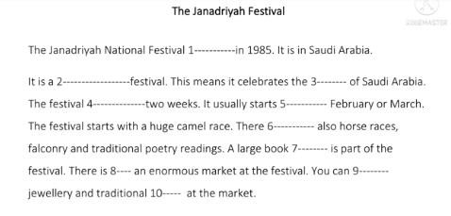
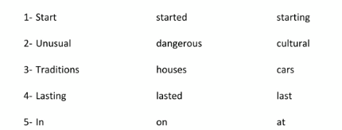

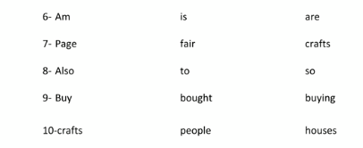

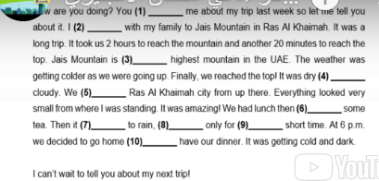
How

      - A- tell B- tells C-told
      - Live b- lived c- living
      - A-then b- the c- than
      - A-So b- and c- but
      - A-See b- saw c- seen
      - drink b- drank c- drunk
      - Is going b- goes c- go
      - And b- but c- so
      - A-the b- an c a
      - And b- but c -nor

Fill in the gabs using the suitable words:
(forget – discuss – tutorial – pace – carefully – independently – instead of)
1- You can go at your own ……………………………… and study when you choose.
2- Online ……………………… are very helpful for students.
3- Listen …………………. to the teacher when he explains grammar points.
4- Our teachers give us topics to ……………… with our groups.
5- The teacher was angry because I …………… my book.
6- I like to study ………………I don’t like group work.
7- I will buy a new I phone …………………. my old mobile.

. Circle the correct answer:
1. I get tired ……………………. working.
a. in b. on c. of
2. I am keen ………………….. studying Math.
a. at b. in c. on
3. I often get in to travel …………………….. forgetting my book.
a. of b. for c. on.
-complete the sentences using these words
freedom Tactile – visual – auditory Education
………… ……learners learn best by listening to audios
……… …learners learn best by moving, and doing experiment.
… …learners learn best by looking at the text and pictures
………………is the ability to choose what you want without being forced
…………………is the process of learning

Complete the paragraph using the past participles of the verbs.
( clean – deliver – design - wash - make - prepare - repair )
I have my clothes …………..1 in Paris. I have my shoes 2 ..…………………….. in Italy. I have my hair …………… 3 every day. I have fresh flowers ………….. 4 to my hotel room, wherever I am. I have all my meals …………….. 5 by my own chefs. I have my car …………….. 6 every day. I never have anything ……………..7 ; I just throw things away when they go wrong , or when I’m tired of them. Am I happy? No, I’m not. I’m bored. I never do anything for myself
Correct the sentences
- If you (have) the opportunity to go to another country, where (you / go) and which places (you / visit)? …………………………………………………………………………………………………
2- What (you / say) to your favorite writer if you (meet) him or her? ………………………………………………………………………………………………
- If you (see) a lion in the street near your house, what (you / do)? …………………………………………………………………………………………………
- Where (you / live) if you (can) live anywhere in the world?
……………………………………………………………………………………….
Unit 3
20-The lifestyle of people in the past was………………
- Settlement B- nomadic c- easy
22- People lived in …………………………in the past.
A-villas B tents C apartments
23-We can see a lot of ………………….. in the desert.
A- gardens B- sand dunes C- traffic
24-The edge of the land near the sea is …………………………………
A- oasis B coast C mountain
25- The person who travelled from one place to another is called ……………………
A- settler B nomad C worker

