13=thirteen
3= three
Part 1
Reading
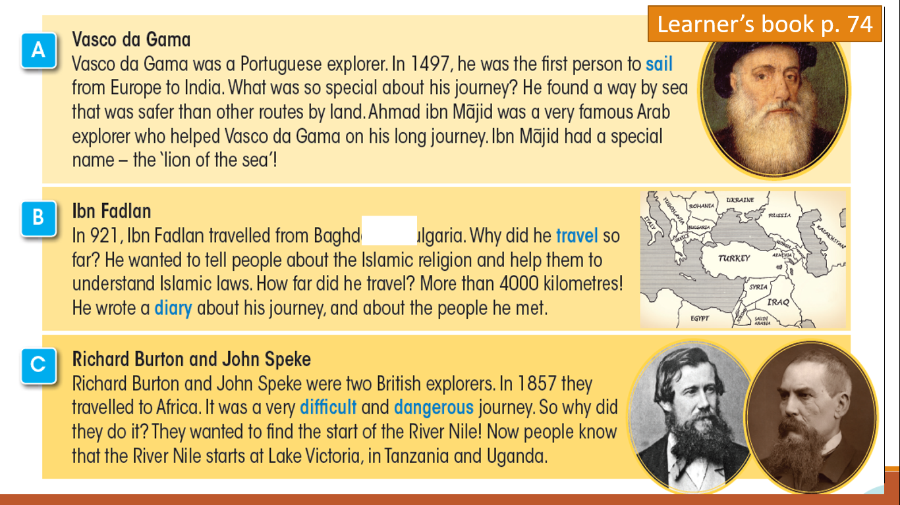
Read. Then answer the questions below .

Who is the lion of the sea?
Ahmad bin Majid.
Omar bin Majid.

Choose the correct answer (5 points):
1.Richard and John were ………. explorers.
British
Emirati
4. The River Nile starts at lake …………...
Victoria
Al Qudra

2.When did Richard and Speke travel to Africa?
1852
1857

3.The journey was fun.
True
False

5.Why did they start their journey?
Because they want to find the start of River Amazon.
Because they want to find the start of River Nile .

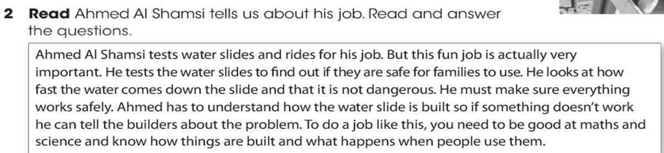
Part 2

1.Ahmed ………… water…… and rides.
tests/slides
eats/slides

2. Why does Ahmed test water slides?
To make sure if it’s safe for families.
To make sure if it’s big or small.
4. Ahmed should be good at ………….. to do this job.
Arabic and math
Science and math

3.Ahmed looks at how slow the water come down slide.
True
False

5. if something doesn’t work in the slides, Ahmed should……………
Tell his family.
Tell the builders.

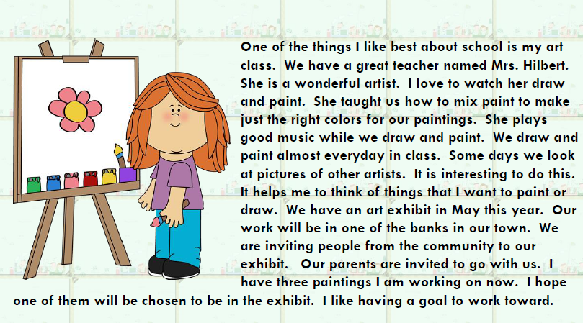
Part 3

5. The girl has …………….paintings for exhibit.
four.
three.
3. When does they have art exhibit?
March
May
2. Mrs Hilbert is ……………. artist.
amazing
lazy
sleepy
- What is the girl’s favorite subject?
Arabic and Math
Art.
4. Where will the art exhibit be?
At school.
At one of the bank
At library

Grammar
Choose the correct answer:
- I ……… a student in grade 6.
- is
- am
- are
- She …… her mother in the kitchen everyday.
- helped
- helps
- helping
- last week, my friend ……… to her grandmother in Dubai.
- went
- goes
- goed
- Everyday , Mariam ……….. her room.
- cleaned
- cleans
- In 2021, We ………. to Japan. It was a fun trip.
- travel
- traveled
Bonus
Choose the correct sentence for each picture:


He is a vet.
He am a vet.
She eat meat every day.
She eats meat every day.

