Name:_____________________________Grade 5_________Date___________________
Final exam Practice
Question 1 ( Bonus )
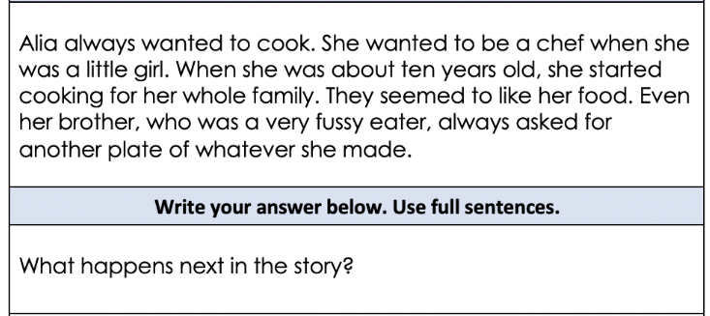
_____________________________________________________________________________________________________________________________________________________________________________________________________________________________________________________________________________________________
--------------------------------------------------------------------------------------------------------------------------------------
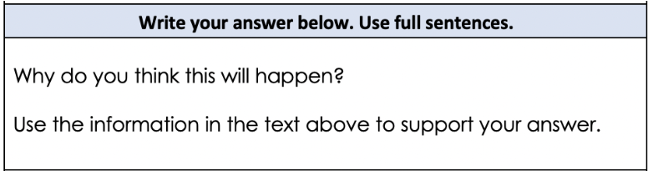_____________________________________________________________________________________________________________________________________________________________________________________________________________________________________________________________________________________________
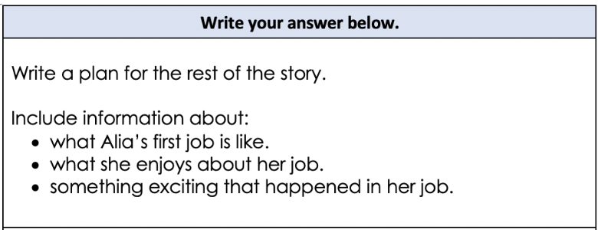
__________________________________________________________________________________________________________________________________________________________________________________________________________________________________________________________________________________________________________________________________________________________________________________________________________________________________________________________________________________________________________________________________________________________________________________________
Question 2 ( 25 marks )


