Level 4.1_Diagnostic_Term 1_2023-2024
Read the questions and choose the correct answer a, b or c.
Yes, he ______ vegetables.
- do like b. does like c. doing like
I ______ got a blue ball.
- having b. has c. have
They are ________ to school today.
- walking b. walked c. walks
The ____ of July.
- twelve b. twelfth c. twelves
He _______ the question.
- didn’t understand b. do understood c. don’t understanding
I ______ like an ice cream.
- do b. want c. would
He likes reading, _____ not writing.
- so b. but c. and
She ______ like the movie and left early.
- didn’t b. don’t c. did
He _______ speak English very well. He is top of the class.
- might b. can c. would
Maryam likes cats, _____ I like dogs.
- but b. and c. also
I _____ a movie last night.
- watch b. watched c. watches
________ did you arrive?
- When b. Who c. What
You look _____
- health b. healthy c. healthily
They _________ to Paris.
- goes b. to go c. went
Hamad like _________ .
- swims b. swimming c. swim
Reem was sick ______ stayed home.
- and b. or c. but
Where _________ you go yesterday?
- did b. do c. does
This is a ________ .
- villa big b. big villa c. villa is big
I’m _______ football right now.
- playing b. played c. play
It ____________ hot yesterday.
- is b. was c. were
My car is ___________ your car.
- behind b. above c. between
They saw _________ football match last night.
- the b. an c. them
Do you know ______ book this is?
- whom b. whose c. who
There is __________ fruit on the table.
- some b. none c. many
A car is ____ expensive than a computer.
- most b. more c. vey
Usain Bolt is the world’s _____________ runner.
- better b. good c. best
I ________ like to go home.
- would b. could c. should
It _____ difficult to drive home in the dark.
- will be b. going to c. will
I ___________ do my homework.
- need b. have c. must
______ ate the apple?
- Whose b. Who c. when
He ______ ran home.
- quick b. quicks c. quickly

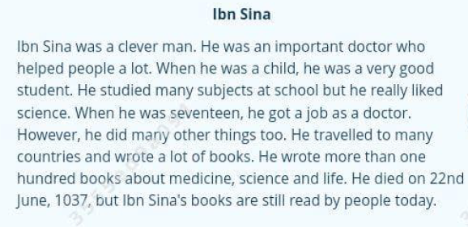
Ibn Sina _________ at school.
- wasn’t lazy b. didn’t work c. couldn’t learn
Why is Ibn Sina still famous now?
- He is still writing new books today.
- He still helps people to get well.
- People are still interested in his work.
What is the text about?
- A famous person’s job
- One person’s life
- The things people like doing

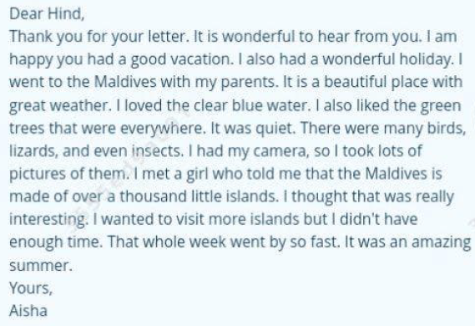
What is the letter about?
- A family holiday b. a special animal c. a weekend trip
What did she take photos of?
- The weather she liked b. the animals she saw c. the girl she met
Why didn’t Aisha go to more islands in the Maldives?
- The weather was too hot
- The girl told her they were too boring
- Her holiday was too short

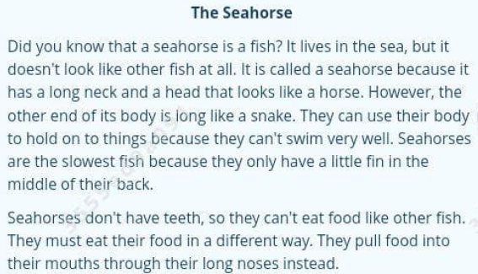
How is a seahorse very different to other fish?
- They are not the same shapes as most fish.
- Their necks are like snakes.
- They swim like horses, not fish.
Why do seahorses find it hard to eat?
- Their head is the wrong shape.
- They have no teeth.
- Their long neck makes it difficult.
This text is mainly _________.
- Discussing how seahorses eat food
- Describing what seahorses look like
- Giving information about seahorses

