

Kingdom of Saudi Arabia
Ministry of Education
………… Education Directorate............
…………..……………….. Intermediate School

20
Total

Midterm Test units 12 & 13
Second Intermediate Grade

Model answer
__________________________________________________________________________________________
Comprehension

/ 4

Read the following then answer the questions:

The winter months are December, January and, February. It's cold and rains in winter. We wear
heavy clothes in winter. The summer months are June, July and August. It's hot in summer. People wear light clothes. They go to the to the park or to the sea, some children like to play football and fly their kites.

A- Put (√ ) for true or ( ᵡ ) for false :

( ᵡ ) | 1. The winter months are June , July and August .
( √ ) | 2. They go to the to the park or to the sea in summer.

B- Choose the right answer:

spring | autumn | winter | summer | 1- It is hot in _______.
jacket | clothes | glasses | shoes | 2- We wear light ____in summer.
_________________________________________________________________
/ 5
Grammar

Choose the right answer:

1- _____ old is Ali ?
D. Where | C. How | B. Who | A. When
2 - I am _________ travel to Jeddah next month .
D. going | C. going to | B. will | A. go
3 - Riyadh is _____ _____.
D. beautiful a city | C. a beautiful | B. a city beautiful | A. a beautiful city
4 - Maybe I_________ drive.
D. am going to | C. go | B. will | A. am going
5 . Jane: Will it be sunny tomorrow? Amira: No, ___ ____ .
D. it will | C. won't it | B. will it | A. it won't.

Vocabulary
/ 4

A- Choose the best answer to fill in the blank:
1. This place is ____. You can learn about traditions from around the world here.
D. unique | C. peaceful | B. exotic | A. cultural
2. This place is ____. It was built thousands of years ago .
D. modern | C. historical | B. adventurous | A. noisy
3- It’s __________ today. Hold on to your hat!
D. hot | C. cold | B. windy | A. funny
4- ______ is usually sunny, really hot, and very dry
D. cloud | C. summer | B. rain | A. winter
B- Put the right word under its picture:
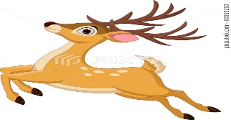 | 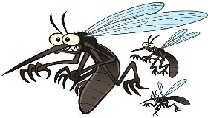 | 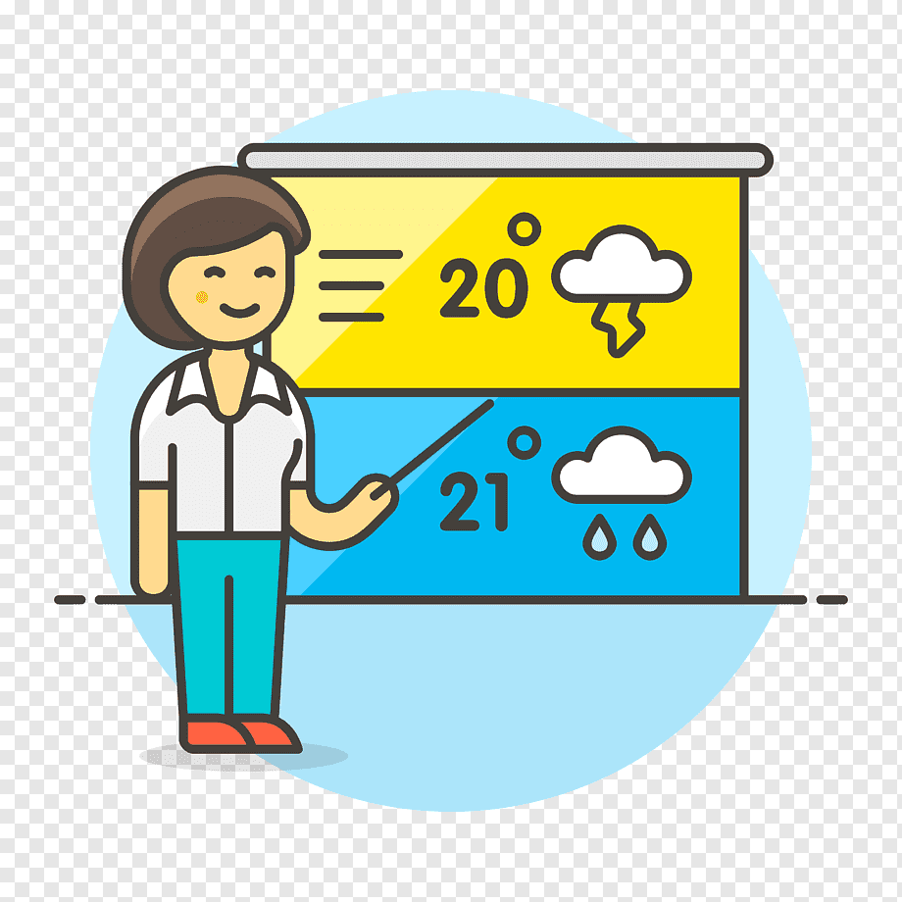 | 
buck | mosquitoes | forecast | sunny
sunny , forecast , buck , mosquitoes
/ 4

_______________________________________________________________________________
/ 3
Orthography

Choose the correct letter:
g | s | v | 1. I live on an i__land .
r | t | d | 2. We’re staying in a comfortable ho__el .
n | h | m | 3. The cli__ate in the city of Jazan is very hot .

Good luck T.

