

Kingdom of Saudi Arabia
Ministry of Education
………… Education Directorate............
…………..……………….. Intermediate School

20
Total

Midterm Test units 9 & 10
Third Intermediate Grade

Model answer
__________________________________________________________________________________________
/ 4
Comprehension

Read the following then answer the questions:

Albert Einstein was born in 1879 in Ulm, Germany. When he was a child he learned things very slowly. Albert didn’t speak until he was three years old. His parents worried about him. The principal of his school told his father. “your son will never make a success of anything. His grades in school were bad. The only thing he liked to do was play violin.

A- Put (√ ) for true or ( ᵡ ) for false :

( ᵡ ) | 1. Albert Einstein was born in Italy.
(√ ) | 2. He learned things very slowly when he was a child .

B- Choose the right answer:

six | five | three | four | 1- He didn't speak until he was _____ years old.
not bad | bad | excellent | good | 2- His school grades were ______ .
_________________________________________________________________
/ 5
Grammar

Choose the right answer:

1- The computer ____________________ I bought does not work well.
D. Where | C. How | B. Who | A. Which
2 - We were sitting in the café when a thief _____ my bag!
D. was stealing | C. stolen | B. stole | A. steal
3 - I __________to book a room.
D. may | C. could | B. would like | A. can
4 - They stop_____ tennis in the winter. .
D. playing | C. play | B. plays | A. played
5 . Have you _____ the dishes yet?
D. did | C. done | B. does | A. do

Vocabulary
/ 4

A- Choose the best answer to fill in the blank:
1. He was talking on his _____________.
D. brother | C. house | B. cell phone | A. car
2. The ______that grow in the city garden are very colorful .
D. food | C. carpet | B. books | A. flowers
3- You look at yourself in the _______ when you brush your hair.
D. sink | C. mirror | B. toothpaste | A. bed
4- people using an escalator instead of the _______.
D. stairs | C. bus | B. train | A. cell phone
B- Put the right word under its picture:
 | 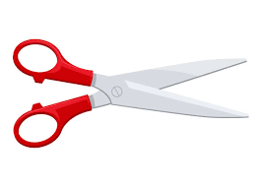 | 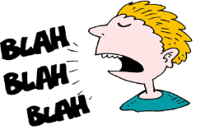 | 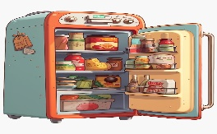
nail polish | scissors | talkative | refrigerator
scissors , talkative , refrigerator, nail polish
/ 4

_______________________________________________________________________________
/ 3
Orthography

Choose the correct letter:
a | u | y | 1. He was waiting for the b__s. .
r | t | d | 2. The artist is talking about his pain_ng .
r | h | m | 3. I can’t stand people who throw litte__ in the street.

Good luck T.

