
Kingdom of Saudi Arabia
Ministry of Education
……..Education Directorate
………………… School
English Language
elementary Grade 3rd
2nd period Exam
…………….\20
نموذج الحل
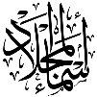


قناتي على التلقرام
Asma's world
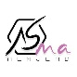
……\ 4 marks

General questions

A.Answer the questions
I want to try scuba diving | 3 | What chores do you do? | 1
I feed the fish. | 1 | What is she doing now? | 2
She's eating a snack. | 2 | What sport or activity do you want to try? | 3
Yes, he does. | 4 | Does he vacuum the floor? | 4

Controlled Writing
……\ 1 marks
A-reorder.
1-is -Pottery - boring
a-boring is pottery b-Pottery is boring
……\ 4 marks

Reading short sentence
 | 1- He folds the laundry ( )
 | 2- Rock climbing is the most difficult ( )
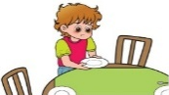 | 3- He Sets the table.( )
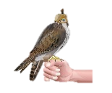 | 4- Many people in Saudi Arabia like falconry ( )
A-Put ( ✔ ) or ( X )

……\ 4 marks

Grammar
A-Choose the correct answer.
c-does | b- do | a-play | 1- I ……… tennis.
c- feeding | b- feeds | a- feed | 2- He is ……the fish.
c- set | b- sets | a- setting | 3- I cook and ………the table.
c-most exciting | b-more exciting | a- exciting | 4- Horse riding is……. than cycling.

Vocabulary

A.Choose the correct word under each picture
……\ 5 marks

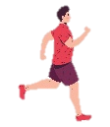 |  |  | 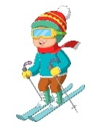 | 
jog | drink | fan | ski | smile
bear | ski | car | pottery | robot
……\ 2 marks

Orthography
A. Fill in the missing letters


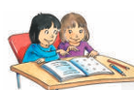

1-gol…..
(u – o – f )
3-sist…..
ar -ai -er))
4-doct….
or– er- ar))
2-h……r
(oy- ai – ee)


Your teacher:

Your teacher …..:…………………………….

