


وزارة التعليم
الإدارة العامة للتعليم بمنطقة ......................
مدرسة .........................................
التاريخ: / / 1447هـ
الصف: الثالث الابتدائي
الزمن: ساعتان
المادة: اللغة الإنجليزية

أسئلة اختبار مادة اللغة الانجليزية للصف الثالث الابتدائي
للعام الدراسي 1447 هـ
الفصل الدراسي الثاني
عدد الأوراق : 4

اسم الطالبة : ........................................................................
رقم الجلوس : .........................................................................
اليوم : ...............................................
التاريخ : .......... / ........... / 1447 هـ
الزمن : ...........................

 | Questions | Mark | Student's mark
Q1 | General Questions | 8
Q2 | Controlled Writing | 7
Q3 | Reading Short Sentences | 5
Q4 | Grammar | 7
Q5 | Vocabulary | 8
Q6 | Orthography (spelling) | 5
Total : |  | 40
المصححة : ...............................................................التوقيع :.....................................
المراجعة : ...............................................................التوقيع :.....................................

معلمة المادة :

......................................................

وزارة التعليم
الإدارة العامة للتعليم بمنطقة ......................
مدرسة .........................................
التاريخ: / / 1447هـ
الصف: الثالث الابتدائي
الزمن: ساعتين
المادة: اللغة الإنجليزية

الدرجة رقماً |  | الدرجة كتابة |  | اسم المصحح | توقيعه | اسم المراجع | توقيعه
الدرجة رقماً | 40 | الدرجة كتابة | درجة فقط
اختبار اللغة الإنجليزية نهائي – الدورالاول – للصف الثالث – الفصل الدراسي الثاني 1447هـ

8
General Questions:
- What did you do over the weekend? |  | Yes, it does. It has a big yellow bus.
- Where did you go with your family? |  | I should do some exercise.
- What’s the matter? |  | It takes about two hours.
- What time does your school start? |  | I’m going to the candy store.
- Where are you going? |  | It starts at 7:00
- How long does it take to get there? |  | I have a stomachache.
- What should you do to live a healthy life? |  | We went to an adventure park.
- Does your school have a school bus? |  | I cooked a big breakfast.
  - Match the questions with the correct answers:

- Controlled Writing:

7
  - Rearrange the words to form sentences:
    - some – I – cakes – want
……………………………………………..
    - opposite – It’s – bus stop – the
……………………………………………..
    - to – Listen – teacher – the
……………………………………………..
  - B. Read and write. Use the words in the box:
very sleepy – very hungry – very thirsty – so cute
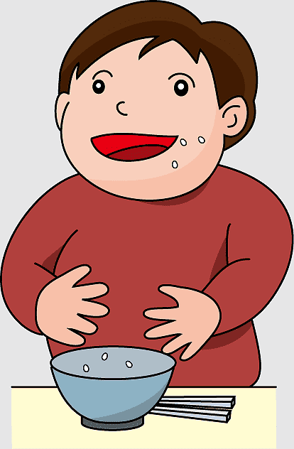  Why did you eat all the soup?  Because I was  ………………….…. |   Why did you drink all the juice?  Because I was  ………………….…. |   Why did you take my panda?  Because It’s  ………………….…. | 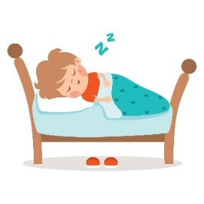  Why did you sleep in my bed?  Because I was  ………………….….
III. Reading Short Sentences:

5
  - Read the sentences then match them with the correct pictures:
 |  | 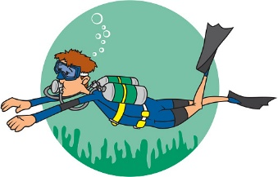 |  | 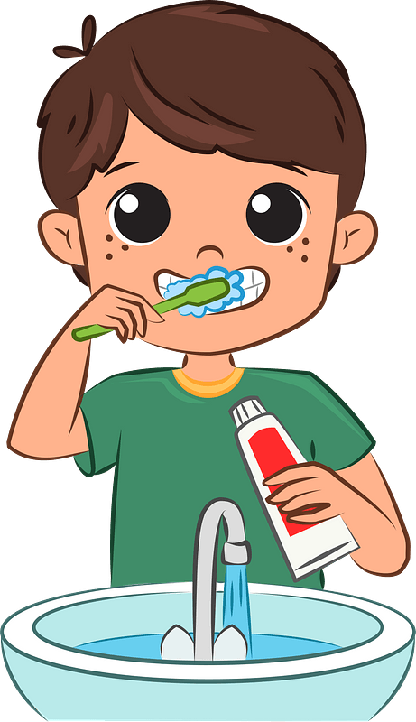
a-_I’d like apple juice.  b-_I’d like orange juice. |  | a-_I’m going skiing.  b-_I’m going diving. |  | a-_I eat breakfast.  b-_I brush my teeth.
 | 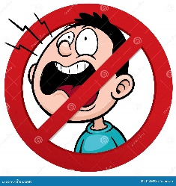 |  | 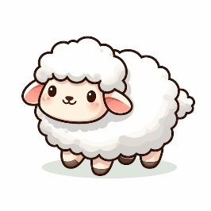
 | a-_Don’t shout  b-_Listen to your teacher |  | a-_I had a little cat.  b-_I had a little lamb.

- Grammar:
  - Choose the correct answer:

7
    - I (was – am) sick last weekend.
    - How (many – much) milk do you drink?
    - I’m going to (shop – to shop) for new clothes.
    - Did you (get up – got up) early this morning?
    - There (is – was – are) books on the desk.
    - He (am – is – are) going to the supermarket.
    - You (should – shouldn’t) eat three meals a day.

8
- Vocabulary:
  - Write the words under the correct pictures:
- trampoline 2- projector 3- meat 4- sleepy
5- skateboard 6- rainbow 7- PE 8– rock climbing

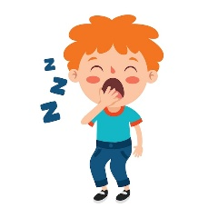 | 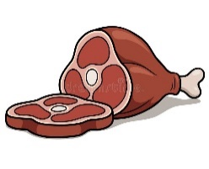 | 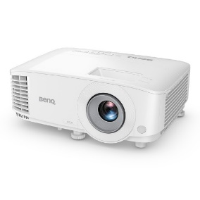 | 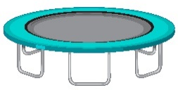
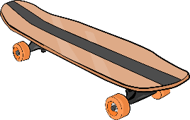 |  |  | 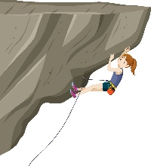

5
- Orthography:
ir – gh – nd – sc - ur
  - Fill in the missing letters:
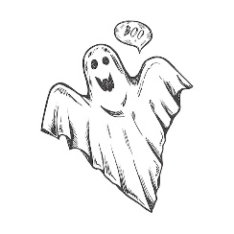
 |  | 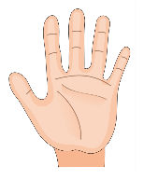 | 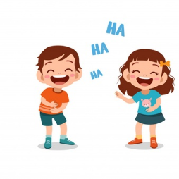   | 
b__ __ger | __ __ary | ha__ __ | lau__ __ | b__ __d

